**Neck, shoulders and upper back**

**Initial Assessment**

|  |  |  |
| --- | --- | --- |
| **Presenting Symptom/Chief Complaint** | | |
| Neck pain for 5 years, aggravated by work extended to both shoulders and upper body. | | |
| **Main Signs and Symptoms** | | |
| Sudden onset and limitation of movement in turning the neck from side to side after repeated acute attacks without treatment. | | |
| **Other Signs and Symptoms** | | |
| Stiffness and rigidity due to wind cold invasion and neck sprain. | | |
| **TCM Diagnosis and Treatment (identified TCM disease, TCM differentiation of syndromes)** | | |
| The predisposing factor liver QI stagnation with liver **Yang** rising. | | |
| **Treatment Principles and Strategies** | | |
| Treatment principles-expel wind and treat the upper part of greater Yangchannels (UB). | | |
| **Treatment Plan (Modalities; acupuncture, herbal, dietary, manual therapies), frequency and duration** | | |
| Acupuncture only with local joints play a primary role by tonification method and distal points with reduction. | | |
| **Any other Advice Given to Patients** | | |
| Local joints: LLB 10(bilateral), DU 16 and GB 20(bilateral). Back of neck and shoulders pain due to wind. GB21-billateral relaxation of trapezius muscle. Distal points: LLB60 (bilateral) due to the greater Yang channel. Due to chronic condition SI channel joints involved. SI-II, SI-12, SI-13(bilateral). Due to tenderness on diagnosis. | | |
| **Practitioner:** | **Date:** | **Signature:** |

**Neck, shoulders and upper back**

**Daily Charting____________________________________Patient Name**

**Date:**

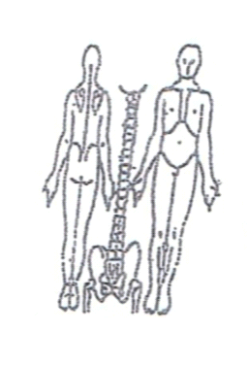 **Working Diagnosis:** Neck, upper back, shoulder pain due to chronic

obstruction pain syndrome (wind, cold, dampness,) with liver QI stagnation.

S: Pain 3-4 on pain scale. Sleep distortion. Low energy. Radiation to upper back and shoulders.

O:

Treatment (P) Local joints: LLB 10(bilateral), DU 16 and GB 20(bilateral). Back of neck and shoulders pain due to wind. GB21-billateral relaxation of trapezius muscle. Distal points: LLB60 (bilateral) due to the greater Yang channel. Due to chronic condition SI channel joints involved. SI-II, SI-12, SI-13(bilateral). Due to tenderness on diagnosis.

(A) According to initial assessment treatment plan

**Date:_**

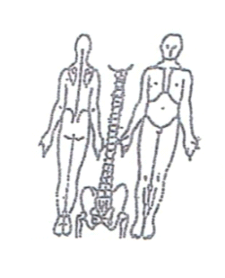**Working Diagnosis:**

S: Pain-the same. Sleep disturbances, low energy level.

O:

Treatment (P) Treatment-the same

(A)

**Date:_**

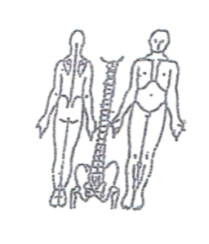**Working Diagnosis:**

S: Pain 3-4 on pain scale. Sleep-better. ROM-increased.

O:

Treatment (P) Insertion of the needles with the patient movement of the neck.

(A)

**Date:**

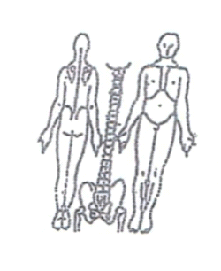

**Working Diagnosis:**

S: Pain-the same. Energy level . ROM

O:

Treatment (P) According to the treatment plan.

(A)

**Date:_**

**Working Diagnosis:**

S: Pain 2-3. Sleep better. Energy level normal, ROM the same.

O:

Treatment (P) According to the treatment plan.

(A)

**Date:___**

 **Working Diagnosis:**

S: Pain 2-3. ROM normal. Energy level N. Sleep well.

O:

Treatment (P) According to the plan + moxa.

(A)

**Date:__**

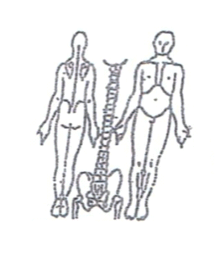**Working Diagnosis:**

S: No pain. ROM-N. Energy level N. Sleep N

O:

Treatment (P) Acupuncture, exercises, warm up diet.

(A)